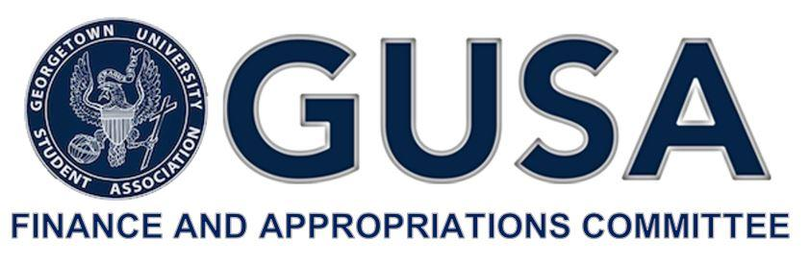

**Timeline Application Process for FY21**

* **Monday, February 10**
  + The application for funding will be made available at 9:30 AM.
* **Friday, February 21**
  + The application for funding will be due at 6:30 PM.
  + No applications will be accepted after this time.
* **Sunday, February 29**
  + Budget Summit will take place at 9:30 AM in the Leavey Program Room.
* **Thursday, March 5** 
  + Release of the First budget report at 5:00 PM.
* **Monday, March 16**
  + Appeals will take place at 7:30 PM. Location TBD.
* **Friday, March 20**
  + Release of the final budget report at 5:00 PM.
  + Final report will be sent to the GUSA Senate for approval.
* **Sunday, March 22\***
  + Approval of the final report by the GUSA Senate.

*\* Note that this is a tentative date as the GUSA Senate may initially reject the final budget allocation. In such case, the final report would be presented for approval to the GUSA Senate on Sunday, March 29.*